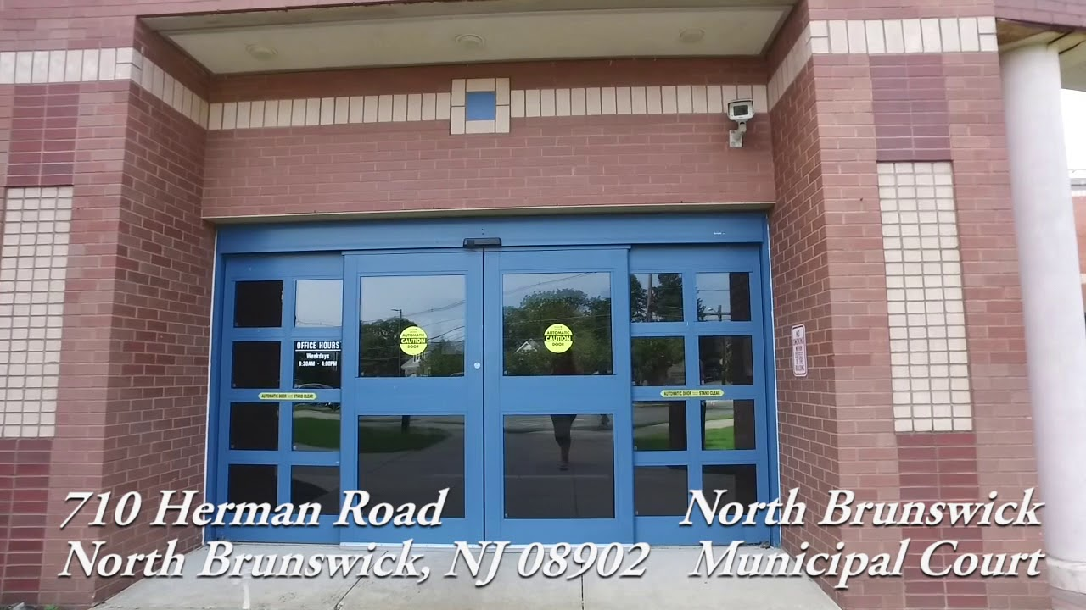
Hello 3rd Grade Chorus! I have some special news. We have been asked to sing “God Bless America”
along with 4th grade chorus students from Livingston Park Elementary School at a special community prayer
night at the North Brunswick Municipal Building, next Thursday night, June 14th at 6pm.

PERFORMANCE: Judd (3rd Grade) and Livingston Park (4th Grade) will sing God Bless America 6/14/18.
PERFORMANCE TIMES: Families will bring their children at 5:30am to the front lawn of the Municipal Building.
FAMILIES: Families stay with their children until the end of the ceremony.
LOCATION: The front lawn of the Municipal Building; 710 Hermann Road.
CLOTHES TO WEAR: Students should wear white on top and black on the bottom.

See you soon! Ms. Perryman (Email: eperryman@nbtschools.org) (Blog: juddsong.blog)
--------------------------------------------------------------------------------------------------------------------------------
I give my child permission to participate in the Community Prayer Night.
I understand that I will stay with them throughout the entire event.
The permission slip due date is: Wednesday June 13th

STUDENT’S FIRST/LAST NAME:

PARENT’S FIRST/LAST NAME:

CELL PHONE/EMAIL:

I UNDERSTAND THAT I WILL STAY WITH MY CHILD THROUGH THE ENTIRE EVENT:

