JUDD CHORUS/ADV. REC. SCHEDULE DEC 4-JAN. 5, 2018!
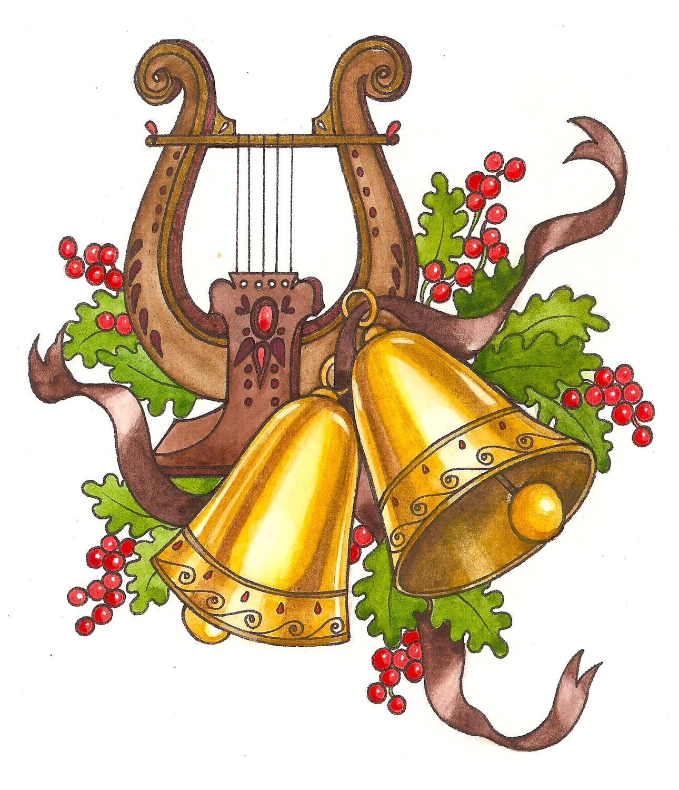http://juddmusic.wordpress.com/
Please check the schedule carefully (especially Birdie actors) for longer rehearsal times and extra days.
Monday Dec. 4 WINTER CONCERT DAY!
NO MORNING OR RECESS REHEARSALS
9:30am Assembly at Judd/7pm Concert at North Brunswick High School
7pm Concert at NBTHS (students come at 6:30pm)

Tuesday Dec. 5
8:15am 3rd Grade Chorus RED OFFICERS All 3rd Gr Chorus @ Recess
No 4th Grade Chorus @ Recess Birdie 3:30-5:30pm (All scenes)

Wednesday Dec. 6 NO REHEARSALS

Thursday Dec. 7
5th gr. chorus at 8:15am No Recess Rehearsals

Friday Dec. 8
Adv Rec @ 815am RED OFFICERS All Birdie Alberts/Rosies @ recess

Saturday Dec. 93 3RD GRADE CHORUS SINGS @ SUYDAM FARMS @ 12PM!
49 Skillman Lane Somerset, NJ. Come @ 11:30am/Families stay with students

Monday Dec. 11
Birdie @ 815am No Recess Rehearsals
Ta TC Pizza Party @ Recess (don't bring lunch/come to music room that day)

Tuesday Dec. 12
3rd Gr. Chorus @ 8:15am BLUE OFFICERS No Recess Rehearsals
Lillis TC Pizza Party @ Recess (don't bring lunch/come to the music room that day)
Birdie Rehearsal 3:30-5:30pm (All scenes come to rehearsal)

Wednesday Dec. 13
4th Grade Chorus @ 8:15am BLUE OFFICERS No recess rehearsals
Swercheck-Lopez TC Pizza Party @ Recess (don't bring lunch/go to music room that day)

Thursday Dec. 14
5th grade chorus @ 815am 4/5th Grade P2 @ Recess

Friday Dec. 15
Adv Rec @ 815am RED OFFICERS “Birdie” Alberts/Rosies @ recess

Monday Dec 18:
Birdie @ 815am 3rd Grade Chorus P1 @ Recess

Tuesday Dec 19:
3RD GRADE CHORUS @ 8:15AM RED OFFICERS 3rd P2/4th P1 @ recess
Tues. Dec 20th COSTUME PARADE 330-530 (All scenes-Bring Costumes to School)

Wednesday Dec 20
4th Grade Chorus @ 8:15am GREEN OFFICERS 5th Gr Girls @ Recess
3rd Grade SongFest for K/1/2 in Cafe at 9:10am

Thursday Dec 21
5th gr. Chorus at 8:15am 4/5th P2 @ Recess

Friday Dec 22
4/5th gr adv rec @ 8:15am RED OFFICERS

Tuesday Jan 2
3rd Grade Chorus @ 8:15am BLUE OFFICERS 3rd P1/4th P1 @ recess
Birdie-All Actors 3:30-6pm Run The Show

Wednesday Jan 3
4th Grade Chorus @ 8:15am RED OFFICERS 5th Grade Girls @ Recess

Thursday Jan 4
5th Grade Chorus @ 8:15am 4/5th P2 @ Recess

Friday Jan 5
4/5th Advanced Recorders @ 8:15am
Birdie-All Actors 3:30-6pm Run The Show

“BYE BYE BIRDIE” IS COMING SOON!
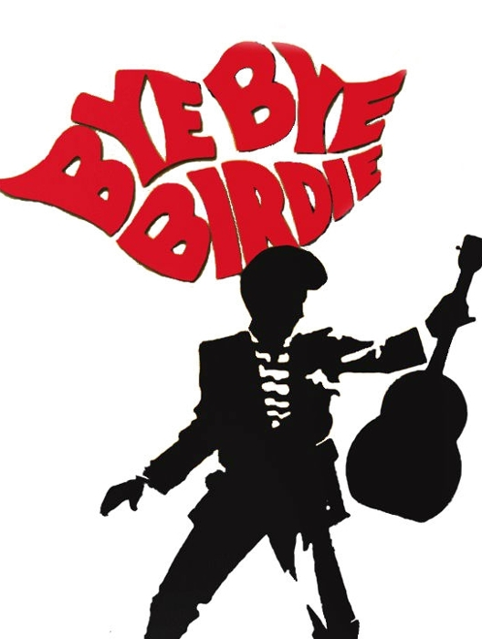
9:30AM @ JUDD ON JAN. 16, 2018
7PM @ NBTHS ON JAN. 16 & 18, 2018

