SUMMER ENRICHMENT PRESENTS ALICE IN WONDERLAND!
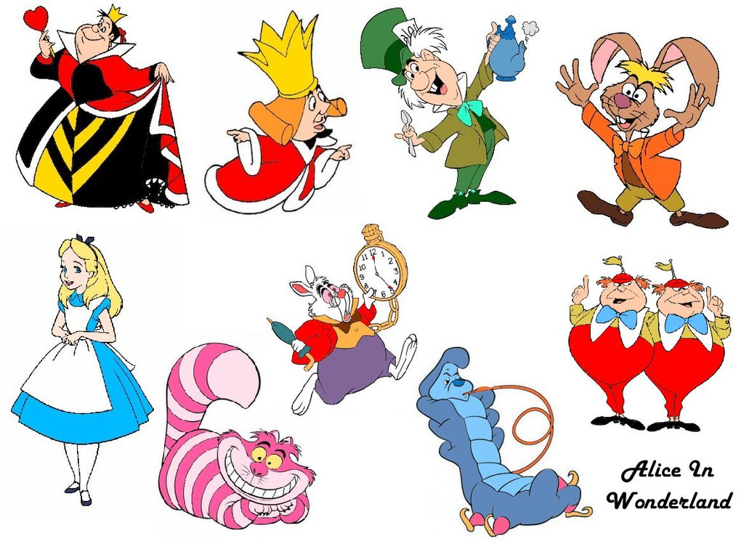
Hello! Happy Summer Enrichment! All of Ms. Perryman’s classes (Theater Review/Sing Your Heart Out) will present “Alice in Wonderland.” We are also excited to have Ms. Fackelman’s music maker class join us as in the Alice in Wonderland ensemble this year! The show will take place on Monday July 31st, 10am, at North Brunswick High School. Students will come at regular time to summer enrichment on their last day and meet Ms. Perryman on stage.
See below for special dates and costume information. Students are asked to provide a costume for the production and any makeup they would like to wear. Costume suggestions are enclosed. Check out your closets and especially Pinterest for fun DIY ideas.
There will be a sneak peak performance at Summerbration on Wednesday night, July 26th. We would like all students to wear an Alice in Wonderland tee-shirt for that performance. Please see below for details.
MEMORIZED: On Monday July 17th, theater students should have their parts completely memorized. This includes memorizing their cue line (the line before they come in.)
COSTUMES: By Tues. July 25th, Students bring their costume to Ms. Perryman for approval.
T-SHIRTS: By Monday July 24th, students are asked to bring in $12.00 for their Alice in Wonderland t-shirt. Please bring cash only and fill out form below.
DRAWING: By Thursday July 20th, design a picture for our program and win a prize!
SUMMERBRATION: On Wednesday July 26th (6:45-8:15pm), Students perform a sneak peak of our play at the high school cafeteria. Students wear their Alice in Wonderland shirt.
-------------------------------------------------------------------------------------------------------------------------------
FIRST AND LAST NAME (please print:)
SHIRT SIZE (Please choose:) YM YL AS AM AL
AMOUNT ENCLOSED (CASH ONLY):
DRESS REHEARSAL: On Thurs. July 27 (during enrichment) Ms. Perryman’s students wear their costume to school for a rehearsal between 10-12:15pm during summer enrichment.
PERFORMANCE: Thurs. July 31st Ms. Perryman’s students come to school dressed and ready to go at 830am for a final rehearsal before the 10am performance. They wear makeup of their choosing. Families and friends are invited to attend!
PROPS NEEDED: Please let me know if you have any of the props: tea set, big clock, paint brushes, fake flowers, and playing cards. Anyone have a croquet set the Queen and I could borrow?=) Thanks!
COSTUME IDEAS:
Pinterest ideas:https://www.pinterest.com/explore/alice-in-wonderland-costume/
SING YOUR HEART OUT/MUSIC MAKERS WEARS A COSTUME OF THEIR CHOICE BELOW.
THEATER REVIEW PERIOD 2 WEARS AN OUTFIT FOR THE GARDEN
THEATER REVIEW PERIOD 3 WEARS THE COSTUME OF THEIR CHARACTER
NARRATOR- White shirt/black pants or skirt; jacket if wanted
ALICE-Blue dress/white apron, white shoes (no gym shoes,) headband
WHITE RABBIT-White sweatshirt/sweatpants; bunny ears; clock, red bow tie, tail
DOORKNOB-Brown shirt-pants; posterboard with picture of door/opening for student’s head
THE GARDEN Solid color bright shirts/black pants; hat with flowers on it. (check dollar tree)
TWIDDLE DEE AND TWIDDLE DUM –Yellow shirts, red pants, blue bow tie, red hat w/flag
CATERPILLAR Headband, peace sign; sun glasses, striped clothes, antenna
CHESHIRE CAT –gray or black shirt and bottom/cat ears and tail
MAD HATTER–Top Hat, white shirt, crazy makeup, brown/black pants/dress shoes
MARCH HARE–Bunny ears, white shirt, crazy makeup, brown/black pants/dress shoes
QUEEN-Fancy red/black dress, crown, white face, blue eyeshadow, red lips, stick with heart

