ATTENTION 3/4TH GRADE: TRYOUT FOR THE JUDD ADV. RECORDERS 2017-2018
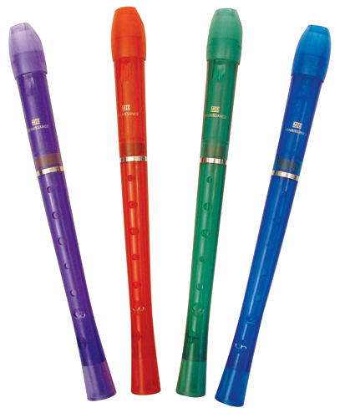
If you would like to tryout to an advanced recorder…..
- Come to school at 8:15 on Thursday June 8th.
- Bring your recorder.
- Bring this sheet completely filled out.
- Play a song from recorder karate/music class or something else you know.
- Show your best behavior and recorder performance.

- Print your first and last name:

- Write your family email:

- How much do you like music & recorders? Circle the answer.

3=SO MUCH! OMG! I live and breathe music. Don’t tell anyone, but sometimes, I sing in the shower. My recorder is my bestie!

2=It’s ok, I guess, whatever dude=/ Maybe I’ll try out if there are some good looking people. (shrugs shoulders)

1=I don’t really care for music BUT my best friend is making me tryout. If I don’t, they won’t share their chicken nuggets with me.

- Students that are chosen are loyal to the group in 4/5th grade. They do a lot of fun performances throughout the year. They have played at all the concerts, Heritage Day, North Brunswick TV at the BOE Meeting, School intercom for Read Across America, etc.. How dedicated are you?

3=I am SO excited. I will be at rehearsals unless I get attacked by a zombie Ipad.

2=I will come sometimes (when I don’t feel like playing with my spinner anymore.)

1=I want to try out but I will NEVER show up for rehearsals. I need my beauty sleep.

- Write three complete sentences explaining why you should be chosen.

