3RD GR. CHORUS “NIGHT AT THE MOVIES” AUDITION RESULTS!
“NIGHT AT THE MOVIES” TUESDAY MARCH 14, 2017
9:30 ASSEMBLY AND 7PM CONCERT AT JUDD ELEMENTARY SCHOOL

SEE THE ACTOR/CHIME/SOLO REHEARSALS!
Mon @ 8:15-Actors
Mon @ Recess-Soloists/Tone Chimers
IMPORTANT:
In order to perform specialty part, students must do
homework & attend all rehearsals unless they are sick from school.

ACTOR/ACTRESSES
(REHEARSAL-Mon @ 8:15)
Kevin Benedict, Anika Chitoor, Arnav Dogra, Melissa Ganae, Andrew Khislavsky,
Sarah Levine, Troy Lyles, Khadija Moro, Tejas Patel, Mooseray Sheriff,
William Shimp, Jadalynn Speed, Alicia Taylor
VOCAL SOLOISTS
(REHEARSAL-Mon @ recess)
Ashantie Burrell, Brianna Clark, Elizabeth Close, Isis Dormer, Beyonca Hatcher,
Jada Lewter, Hanaah Oshin, Pavan Patel, McKenna Rizk
TONE CHIME PLAYERS
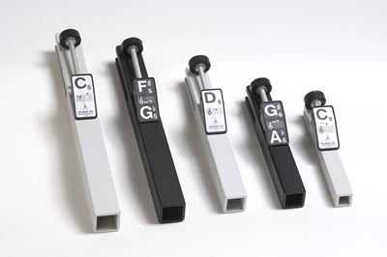(REHEARSAL-Mon @ Recess)
Amirah Akalifa, Temi Akanbi, Melissa Arias, Cederic Bernard, Michael Boakye,
Joshua Bonsu, Luke Chichowski, Dean Craig, Atharvan Deshmukh, Ja’ir Eato,
Jessica Forero, Gabriela Galuska, Josh Goldenfarb, Kadence Green, Ummi Hashim,
Simran Hathiramani, Dean Kamel, Zebo Khasinova, Victoria Longo,
Ina McCauley, Precious Ogungbemi, Sonya Panchal, Khushi Patel,
Dorian Price, Angel Rodriguez, Abu Samura, Paige Scioscia,
Giavanna Sgobbo, David Shenker, Kyal Vreeland, Marissa Yanuzzi, Eric Zou

