OUR SCHOOL PLAY IS COMING SOON!

THE 4/5TH GR CHORUS IS PRESENTING “YOU’RE A GOOD MAN, CHARLIE BROWN!

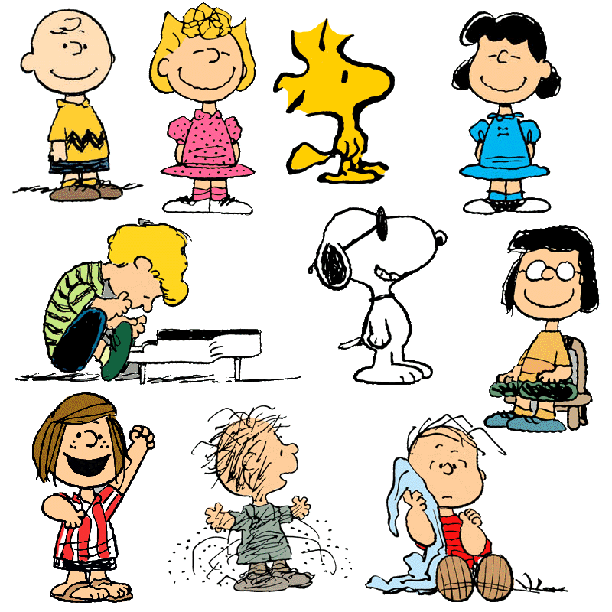

TUESDAY JAN. 17TH

9:30 FOR JUDD SCHOOL

7PM FOR FAMILIES AND FRIENDS AT NBTHS

THURSDAY JAN. 19TH

7PM FOR FAMILIES AND FRIENDS AT NBTHS

(STUDENTS IN CHORUS NEED TO WEAR CLOTHES DESCRIBED BELOW TO ALL PERFORMANCES.)
CHORUS OUTFITS FOR CHARLIE BROWN
SHIRT/TOP: T-Shirt or short-sleeved knit top in your choice of the following colors: yellow, red, purple, blue or pink.
BOTTOMS: Shorts, as described below, are recommended to keep a uniform look among all cast members. However, please feel free to choose your preferred style but color must be black.
SHORTS: Black cotton/twill/chino. Ex- Amazon.com: Dickies Boy’s School Uniform Shorts
PANTS: Black
SKIRTS: Black
LEGGINGS: Black
SOCKS: Crew socks to match your shirt color (yellow, red, purple, blue or pink), OR black crew socks
SHOES: Black. Please note: NO sneakers, NO flip flops
Email Carolyn McCaffrey at cmccaffrey@nbtschools.org with any questions about costumes

