BRUNO MARS “COUNT ON ME”
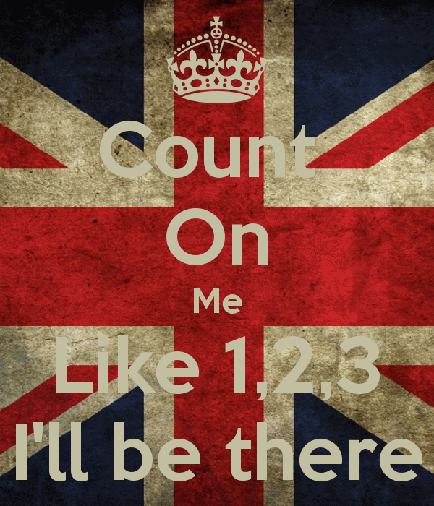
VERSE ONE
Uh huh If you even find yourself stuck in the middle of the sea, I’ll sail the world to find you. If you ever find yourself lost in the dark, and you can’t see, I’ll be the light to guide you. We find out what we’re made of when we are called to help our friends in need.
REFRAIN
You can count on me like 1, 2, 3, I’ll be there, and I know when I need it, I can count on you like 4, 3, 2, and you’ll be there, cause that’s what friends are s’posed to do oh yeah. Oooooooo, oooooo, yeah, yeah.
VERSE TWO
If you’re tossin’ and you’re turnin’ and you just can’t fall asleep, I’ll sing a song beside you. If you ever forget how much you really mean to me, every day I will remind you. We find out what we’re made of when we are called to help our friends in need. (REFRAIN)
BRIDGE
You’ll always have my shoulder when you cry. I’ll never let go, never say goodbye. You know, (REFRAIN)
CODA
You can count on me, ‘cause I can count on you.
http://www.youtube.com/watch?v=yJYXItns2ik

