JUDD IS ALIVE WITH THE SOUND OF MUSIC!
4/5TH GRADE SCHOOL PLAY AUDITION
MONDAY SEPTEMBER 22, 2014
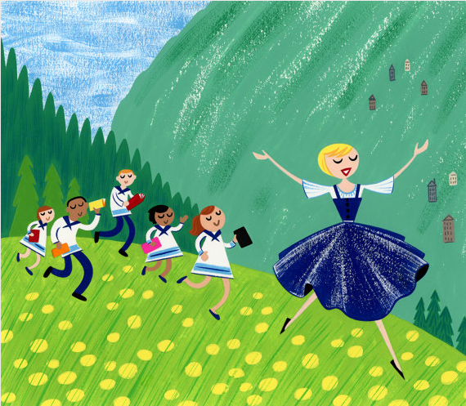

COMPLETE THESE QUESTIONS AND BRING TO AUDITION:

First/Last Name:

Teacher/Grade:

Email:

I would like to be (circle):

- ONLY AN ACTOR

- AN ACTOR AND A SINGER

True or False: I will do any part.

Which character would you most like to play?

AUDITION SCENE
CAPTAIN VON TRAPP: Children, This your new governess, Fräulein (Froy-line) Maria. Give your name at your signal. Fräulein, listen carefully. Learn their signals so you can call them.
LIESL: Liesl. (Lee-zil)
FRIEDRICK: Friedrick. (Free-drick)
LOUISA: Louisa. (Loo-ee-za)
KURT: Kurt.
BRIGITTA: Brigitta.(Bree-gee-ta)
MARTA: Marta. (At the sound for Gretel. She marches forward and forgets to say her name.)
CAPTAIN VON TRAPP: That’s Gretel. Ahem. Now, when I want you, this is what you will hear...
MARIA: Oh, no, sir. I'm sorry, sir! I could never answer to a whistle. Whistles are for animals,
not for children. And definitely not for me.
CAPTAIN VON TRAPP: Fräulein, were you this much trouble at the abbey?
MARIA: Oh much more sir. (The Captain turns to exit.) Excuse me Captain, I don’t know your signal.
CAPTAIN VON TRAPP: You may call me....Captain.
(The Captain exits. The children snicker/laugh. The children are still standing at attention.)
MARIA: At ease. Now that there's just us, please tell me all your names again and how old you are.
LIESL: I’m Liesl, I’m 16 years old and I don’t need a governess.
MARIA: I'm glad you told me, Liesl. We'll just be good friends.
FRIEDRICK: I'm Friedrich (Free-drick) I’m 14 years old and I'm impossible.
MARIA: Really, who told you that Freidrick?
FRIEDRICK: Fräulein Josephine. Four governesses ago.
LOUISA: I’m Brigitta. (Bree-gee-ta)
MARIA: You didn’t tell me how old you were Louisa.
BRIGITTA: I’m Brigitta, (pointing to Louisa), she’s Louisa, she’s 12 years old and I’m 10 and that is the ugliest dress I’ve ever seen.
KURT: Brigitta, you shouldn't say that!
BRIGITTA: Why not? Don’t you think so?
KURT: Why yes, but Fräulein Helga's was ugliest. I'm Kurt. I'm incorrigible.
MARIA: Congratulations.
KURT: What’s Incorrigible?
MARIA: I think it means you want to be treated like a boy.
MARTA: I'm Marta, and I'm going to be 8 on Tuesday. I'd like a pink parasol.
MARIA: Pinks my favorite color too. (Gretel stamps her feet.) Yes, you’re Gretel.(Gretel holds up five fingers) And you're five years old? My, you're practically a lady. I have to tell you a secret. I've never been a governess.
ALL CHILDREN: You don't know anything about being a governess?
---------------------------------------------------------------------------------------------------------------------
(CUT THE INFORMATION BELOW AND GIVE TO YOUR FAMILY)
AUDITION
- Monday September 22nd @ 8:10am
PERFORMANCES
- Wednesday January 21, 2015 @ 9:30am and 7pm @ Judd School
(One cast will be chosen who will perform in both shows)
ALL CHARACTERS: (Open to all 4/5th grade students)
- Reverend Mother, Nuns, Maria, Captain, Baroness, Max, Rolf, Liesl, Friedrick,
Louisa, Kurt, Brigitta, Marta, Gretel
REGULAR REHEARSALS
(beginning the week of Sept. 29/Students are allowed one unexcused absence)
- Monday Mornings @ 8:10 Tuesday Afternoons 3:40-5pm

